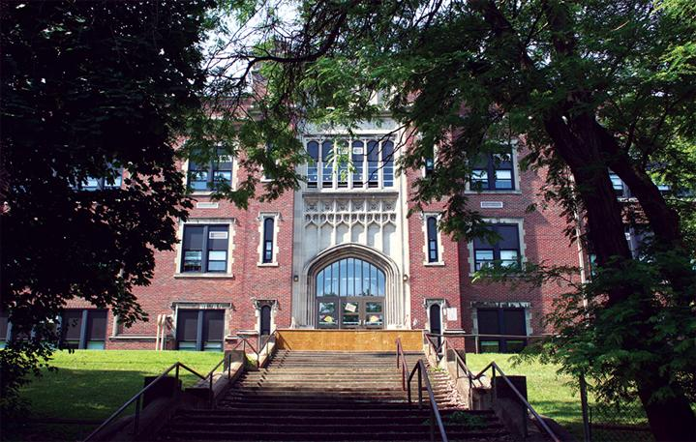

MINIMUM CAPACITY :-
The Minumum intake capacity
of students is between 300-620
children

LIBRARY :-
The Libarary is Available.

CANTEEN:-
The Canteen Facility is Available.

BOARDING :-
No availablility of boarding.

SPORTS :-
There are different categories
sports available.
Girls Volleyball
Boys Volleyball
Football

JOHN F HUGHES ELEMENTARY SCHOOL
UTICA - SCHOOL

School Detail :-
Provide our diverse student population with a high quality education in a safe andorderly school environment. Studentswill engage in lessons that reflect the 21st century learning skillsso they have the knowledge and competencies necessary to be college and career ready.

